**Scrum Methodology**

Team Fruitcakes uses the scrum methodology to organise this project. The Product owner is a second year supervisor and one team member is the scrummaster. Each team member decides their own task for each sprint, as the team has a sprint review for 14 days. In addition to the sprint review, the sprint planning and retrospective are also done during the sprint review session. The selected tasks must be finished within each sprint period. Trello is a tool that is used to manage assigning and tracking tasks in each sprint.

The burndown chart is used to compare ideal task remaining and actual task remaining. The scrum master creates the burndown chart in each sprint as following:

Sprint review 1:

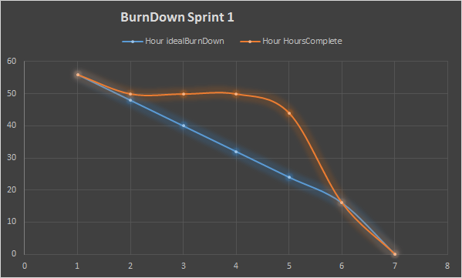

Sprint review 2:

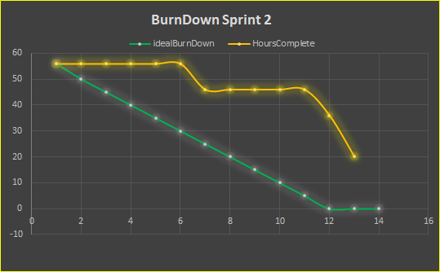

Sprint Review 3:

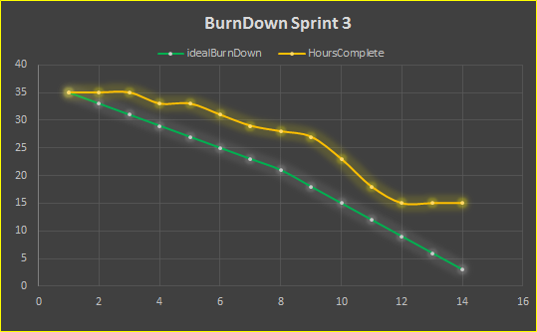

Sprint Review 4:

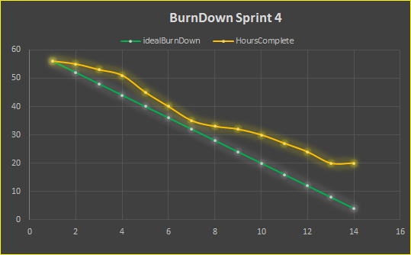

Sprint Review 5:

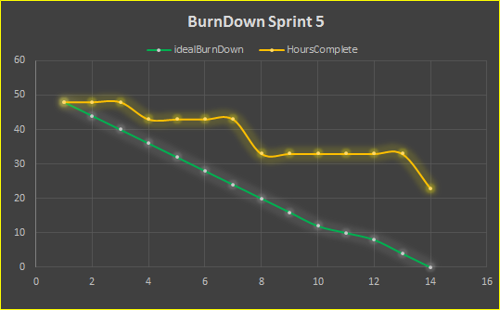

Sprint review 6:

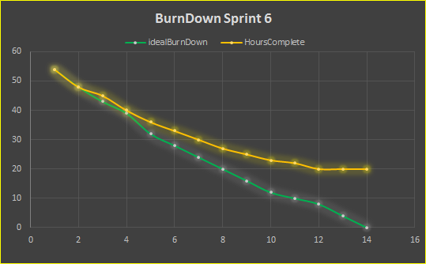

Each task in a sprint is decided to points depending on the difficulty and the task owner’s skill level, team Fruitcakes defined a manday (8 hours) as a point. Referring to the charts above, most of the tasks in each sprint are done. The unfinished tasks from previous sprints are moved to the current sprint. The main cause of unfinished tasks is technical debt, uncontrollable situations. For instance, an examination held during a sprint takes time away from the tasks. In addition, unfinished relevant tasks and the sickness of team members are also technical debt.

The scrum meeting did not occur every day, but the tasks have been followed up on by the scrum master.